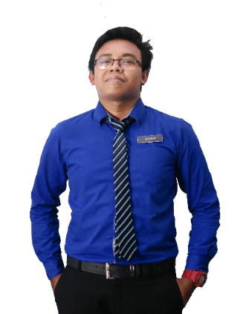S=========================================================================================================================

* Excellent written and verbal communication skills.
* Strong problem-solving and analytical skills.
* Ability to work independently in a fast-paced environment.
* Strong interpersonal skills and positive work ethic.
* Able to coordinate several tasks simultaneously.

**STRENGTH**

* Study Visit to Syarikat Suruhanjaya Malaysia and Malaysia Investment Development Authority
* The Glorious Smash Badminton
* Anugerah Pasukan Terbaik SSN SeriTitiwangsa (Pasukan Bola Jaring)
* Pelajar Terbaik Mata Pelajaran SPM Pendidikan Seni Visual 2015
* Bola Jaring Majlis Sekolah Sukan Malaysia 2015
* Pertandingan Melukis Kain Rentang Karnival Pendidikan Kaunseling Kerjaya
* Pelajar Terbaik Mata Pelajaran Bahasa Melayu 2014
* Pelajar Terbaik Mata Pelajaran Sains 2014
* Pelajar Terbaik Mata Pelajaran Seni Visual 2014
* Pesta Bola Jaring US - Penang International

**ACHIEVEMENT / PARTICIPATION**

2014 - 2015

Sijil Pelajaran Malaysia (SPM)

**SEKOLAH SUKAN SERI TITIWANGSA**

**SEKOLAH MENENGAH KEBANGSAAN SUNGAI BESI**

2011 - 2013

Penilaian Menengah Rendah (PMR)

Dec 2015 - June 2018

Diploma in Corporate Administration

CGPA: 3.32

* Provide an excellent customer service to the company.
* Promote product that are under promotion items.

**EXPERIENCE**

Head of Business Studies Department,

Kolej MASA, Puchong.

Phone: +6014-8209654

**HANIS KAMAL**

Head of General Studies Department,

Kolej MASA, Puchong.

Phone: +6014-8209654

**MOHD HAZDRIN BIN SULAIMAN**

**ROBINSON, THE GARDENS MALL**

**Bed Sheet Department (Part-time)**

resumecreative@yahoo.com

Supervisor

Grand Atelier Bed Sheet Department,

Robinsons, The Garden Mall.

Phone: +6016-3430340

Microsoft Word

B-18-18 PPR Raya Permai, Jalan Landai Permai, Sungai Besi, 57100 Kuala Lumpur

Dedicated and self-motivated individual seeking for a position in a reputable organization to utilize my personal capability and creativity where I can enhance my skills and improve my knowledge. Also willing to face new challenge in fulfilling the company vision and expanding my career.

**CAREER OBJECTIVE**

2016 - 2019

**KOLEJ MASA, PUCHONG**

Female, Single, Malay, 980221-08-****, 21 February 1998

**NURLIANA NAJIHAH**

**SIAW MEI FOONG**

**NURLIANA NAJIHAH BINTI JAHAYA**

Microsoft PowerPoint

**EDUCATION**

+6013-2805916

**REFERENCES**

**LANGUAGES**

English

Malay

Creativity

Teamwork

Leadership

Communication

**PERSONAL SKILLS**

**SKILLS**

Microsoft Excel